**EDUCATIONAL PERFORMANCE TRACKER**

**A Socially Relevant Project Report**

**Submitted to**

**Jawaharlal Nehru Technological University-A, Anantapur**

*In partial fulfilment of the requirements*

*For the award of the degree of*

**BACHELOR OF TECHNOLOGY**

In

**COMPUTER SCIENCE AND ENGINEERING**

**By**

**Project Batch – 29**

**Laya K - 19AK1A0585**

**Koteswara P -19AK1A0578**

**Pavan Kalyan Y -20AK5A0506**

**Jaya Krishna M -20AK5A0507**

**GUIDED BY**

**Asst Prof. T. Srinivasula Reddy**



**DEPARTMENT OF COMPUTER SCIENCE AND ENGINEERING**

**ANNAMACHARYA INSTITUTE OF TECHNOLOGY AND SCIENCES::TIRUPATI**

**(AUTONOMOUS)**

Venkatapuram(V), Karakambadi(Po), Renigunta(M), Tirupati-517520, A.P.

**2019-2023**

**ANNAMACHARYA INSTITUTE OF TECHNOLOGY AND SCIENCES::TIRUPATI**

**(AUTONOMOUS)**

Venkatapuram(V), Karakambadi(Po), Renigunta(M), Tirupati-517520, A.P.

**DEPARTMENT OF COMPUTER SCIENCE AND ENGINEERING**



**CERTIFICATE**

Certified that this is a Bonafede record of the Project Report entitled, **“EDUCATIONAL PERFORMANCE TRACKER”, Done by K. Laya, REG NO 19AK1A0585, P. Koteswara, REG NO. 19AK1A0578, Y. Pavan Kalyan, REG NO. 20AK1A0506, M. Jaya Krishna, REG NO. 19AK1A0570** Submitted to the faculty of Computer Science and Engineering, in partial fulfilment of the requirements for the Degree of BACHELOR OF TECHNOLOGY in Computer Science and Engineering from Jawaharlal Nehru Technological University-A, Anantapur during 2019- 2023.

Date:

Place: Tirupati

**INTERNAL EXAMINER EXTERNAL EXAMINER**

ANNAMACHARYA INSTITUTE OF TECHNOLOGY AND SCIENCES

Venkatapuram(V), karakambadi(Po), Renigunta(M), Tirupati-517520,A.P

DEPARTMENT OF COMPUTER SCIENCE AND ENGINEERING



DECLARATION

We hereby declare that the project titled **“EDUCATIONAL PERFORMANCE TRACKER”** is a genuine project work carried out by us, in **B. Tech (Computer Science and Engineering)** degree course of **Jawaharlal Nehru Technology University-A, Anantapur** and has not been submitted to any other course or university for the award of our degree by us.

|  |  |
| --- | --- |
| **19AK1A0585 –** | **K. Laya** |
| **19AK1A0578 –** | **P. Koteswara** |
|  |  |
| **20AK5A0506 –** | **Y. Pavan Kalyan** |
| **19AK1A0570 –** | **M. Jaya Krishna** |

## ACKNOWLEDGEMENT

The satisfaction that accompanies the successful completion of the task would be put incomplete without the mention of the people who made it possible, whose constant guidance and encouragement crown all the efforts with success.

We avail this opportunity to express our deep sense of gratitude and hearty thanks to **Mr. C. GANGI REDDY,** Hon’ble Secretary of AITS-Tirupati, for providing congenial atmosphere and encouragement.

We show gratitude to **Dr. C. NADHAMUNI REDDY**, **Principal** for having provided all the facilities and support.

We would like to thank **Ms. B. RAMANA REDDY, Assistant Professor & HOD**, **Computer Science and Engineering** for encouragement at various levels of our Project.

We thankful to our guide **T. SRINIVASULA REDDY, Assistant Professor, Computer Science and Engineering** for his sustained inspiring guidance and cooperation throughout the process of this project. His wise counsel and suggestions were invaluable.

We thankful to APSSDC/IGDC and trainers**,** for training us on different platforms and for supporting us throughout our project.

We express our deep sense of gratitude and thanks to all the **Teaching** and **Non-Teaching Staff**

of our college who stood with us during the project and helped us to make it a successful venture.

We place highest regards to our **Parents**, **Friends** and **well-wishers** who helped a lot in making the report of this project.

|  |  |
| --- | --- |
| **19AK1A0585 –** | **K. Laya** |
| **19AK1A0578 –** | **P. Koteswara** |
| **20AK5A0506 –** | **Y. Pavan Kalyan** |
| **19AK5A0570 –** | **M. Jaya Krishna** |

**CONTENTS**

**CHAPTER NO NAME OF THE CHAPTER PAGE NO**

**CHAPTER 1 INTRODUCTION**

1.1 Introduction 1

1.2 Existing system 2

1.3 Disadvantages of Existing system 2

1.4 Proposed System 3

**CHAPTER 2 ANALYSIS**

2.1 Introduction 4

2.2 Software Requirement Specification 4

2.2.1 User requirement 4

2.2.2 Software requirement 4-6

2.2.3 Hardware requirement 6

2.3 Context diagram of Project

2.4 Flowcharts

**CHAPTER 3 DESIGN**

3.1 Introduction 8

3.2 DFD / ER diagram 8-10

3.3 Module design and organization 12

**CHAPTER 4 IMPLEMENTATION & RESULTS**

4.1 Introduction 14

4.2 Explanation of Key Functions 14

4.3 Method of Implementation 15

4.3.1 Output Screens 15-22

**CHAPTER 5 VALIDATION**

5.1 Introduction 23

5.2 Design of test cases and scenarios 23

5.3 Validation 23

**CHAPTER 6 SAMPLE SOURCE CODE 24-50**

**CHAPTER 7 CONCLUSION & FUTURE ENHANCEMENT 51**

**CHAPTER 8 BIBLIOGRAPHY 52**

8.1 References

8.2 Websites

**LIST OF FIGURES**

**S.NO FIG NO FIGURE NAME PAGE NO**

1 3.1.1 Login page for admin 14

2 3.1.2 Login page for students 15

3 3.1.3 Student page 16

4 3.1.4 Admin direction page 17

5 3.1.5 Add student 18

6 3.1.6 Edit/remove student 19-20

7 3.1.7 Update Student 20-21

**LIST OF TABLES**

**S.NO TABLE NO TABLE NAME PAGE NO**

1 1 Data flow diagram symbols 8

2 2 ER diagram symbols 11

**ABBREVIATIONS**

* **DFD**: Data Flow Diagram
* **HTML**: Hyper Text Markup Language
* **PHP**: Hypertext Preprocessor
* **ER:** Entity Relationship

**ABSTRACT**

**EDUCATIONAL PERFORMANCE TRACKER**

Educational Performance Tracker is a web-based Application for Educational institutions to track their student's academic performance and providing the same to their students. It saves information such as a student’s grades of previous years and attendance at a centralized student database and analyses them. To ensure that educational activities are going in the Right direction & to fulfil the purpose of education, an institution will have to track their student’s progress. This application enables them to do so easily. Students can learn about themselves and improve by doing so through this application. Here we are offering constructive feedback, and continuous evaluation of performance can prove to be the turning point in the life of a student.

**CHAPTER 1: INTRODUCTION**

**1.1. INTRODUCTION:**

The login portals that are currently being used by any educational institute is very simple with only a single option for the students to view their results and basically nothing else. These types of portals are not very helpful to either the student or the educational institutions who want to improve their performance.

To provide a way for educational institutions to monitor their student’s performance and for the students to know their academic performance and growth over the years is the reason for the making of this web site.

By offering constructive feedbacks to the students based on their performance, we are building a place for them to monitor their progress and improve themselves.

.

**1.2. EXISTING SYSTEM:**

In the College Login portal, Students can only view their exam results. Students are not getting the proper idea to improve their academic performance. Students are not using their profiles regularly as there is only a results portal. No further feedback and analysis on performance are provided.

**1.3-DISADVANTAGES OF EXISTING SYSTEM**

* In existing system remaining student’s progress is not calculated.
* Student’s growth trajectory cannot be seen.
* Feedbacks are not available in Existing system.

**1.4. PROPOSED SYSTEM:**

* A web-page by using browser, for educational institutions that allows tracking student academic performance. This web provides users with access to grading dashboards. Students can review such data as the overall curriculum progress, individual average grades, attendance, grade by subject, and others by using the graph analysis. It enables the students to fetch the required data at any given instant. Through graph analysis we'll provide instructions to grow the students in both attendance and studies.
* Learning analytics, discriminative and generative classification models are applied to predict whether a student will be able to complete his degree or not. Graphical analytical results show that proposed method significantly outperforms existing methods due to exploitation of student’s information feature sets.

**1.5-ADVANTAGES OF PROPOSED SYSTEM**

* Providing student’s progress over the past few years through the website.
* Feedback based on their performance in each semester.

**CHAPTER 2: ANALYSIS**

**2.1 INTRODUCTION:**

* The student performance analysis system provides an easy way for students in finding their academic attendance report and marks/percentage details along with their progress shown using a graph.
* All the details of student’s attendance and marks are added by the admins. Students can use the credentials provided by their institute to login, view attendance, marks in graph-based format, and get a feedback.
* Teachers can login, add new students to the database, and are able to remove a student from the database if necessary and they can also edit a student’s info. Basically, this system can help to maintain and manage the records of students, and help both the students and teachers**.**

**2.2 SOFTWARE REQUIREMENT SPECIFICATION:**

**2.2.1 USER REQUIREMENT**

As we know that here the user requirements only two things. user need to go to the website with the specified link that we already provided and also, he needs internet resource to access the Website and with these two things user can easily access the website designed for career guidance.

The main thing in this project is only the user may provide their login details to enter the case details which they need to complaint and a proper detail of the case should be provided to the admin.

**2.2.2 Software requirement:**

* XAMPP Control panel
* MYSQL
* Any web browser
* Languages: HTML, CSS, PHP

**XAMPP Control panel:**

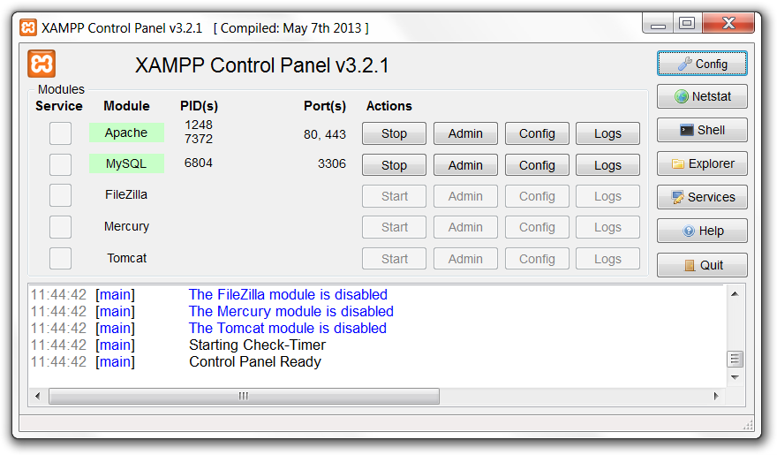

XAMPP is the most popular PHP development environment

XAMPP is a completely free, easy to install Apache distribution containing MariaDB, PHP, and Perl. The XAMPP open-source package has been set up to be incredibly easy to install and to use.

XAMPP is a compilation of free software (comparable to a Linux distribution), it's free of charge and it's free to copy under the terms of the GNU General Public Licence. But it is only the compilation of XAMPP that is published under GPL. Please check every single licence of the contained products to get an overview of what is, and what isn't, allowed. In the case of commercial use please take a look at the product licences (especially MySQL), from the XAMPP point of view commercial use is also free.

**MySQL:**

The SQL part of “MySQL” stands for “Structured Query Language”. SQL is the most common standardized language used to access databases. Depending on your programming environment, you might enter SQL directly (for example, to generate reports), embed SQL statements into code written in another language, or use a language-specific API that hides the SQL syntax.

MySQL Server was originally developed to handle large databases much faster than existing solutions and has been successfully used in highly demanding production environments for several years. Although under constant development, MySQL Server today offers a rich and useful set of functions. Its connectivity, speed, and security make MySQL Server highly suited for accessing databases on the Internet.

What is MySQL database used for?

**MySQL** is a relational database management system based on SQL – Structured Query Language. The application is used for a wide range of purposes, including data warehousing, e-commerce, and logging applications.

**HTML & CSS:**

**HTML** (Hypertext Markup Language) is used to create the actual content of the page, such as written text, and **CSS** (Cascade Styling Sheets) is responsible for the design or style of the website, including the layout, visual effects and background colour.

In the case of HTML, markup instructions found within a Web page relay the structure of the document to the browser software. For example, if you want to emphasize a portion of text, you enclose it within the tags and, as shown here: This is important text!

**2.2.3-Hardware Requirements**

* Laptop or Personal Computer
* Configuration of system
  + Personal Computer or Laptop
  + Windows Version: 8
  + Installed Memory: 4GB
  + ROM : 64GB
  + Processor : Intel Core i3 or higher

**2.3 Flowcharts:**

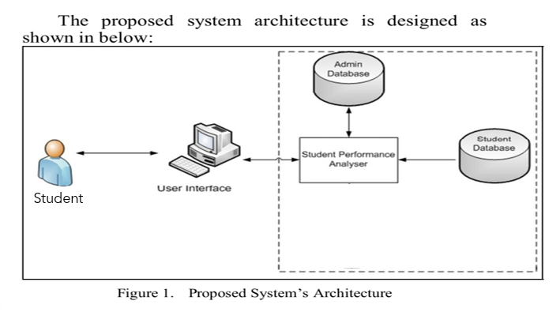

**CHAPTER 3: DESIGN**

**3.1 INTRODUCTION:**

Design is the process of defining the architecture, components, modules, interfaces, and data for a system to satisfy specified requirements. One could see it as the application of systems theory to product development. There is some overlap with the disciplines of systems analysis, systems architecture and systems engineering. If the broader topic of product development "blends the perspective of marketing, design, and manufacturing into a single approach to product development, then design is the act of taking the marketing information and creating the design of the product to be manufactured. Systems design is therefore the process of defining and developing systems to satisfy specified requirements of the user.

**3.2 DFD / ER Diagrams:**

**DATA FLOW DIAGRAMS:**

A full description of a system consists of a set of data flow diagrams.

1. The DFD is also called as bubble chart. It is a simple graphical formalism that can be used to represent a system in terms of input data to the system, various processing carried out on this data, and the output data is generated by this system.

2. The data flow diagram (DFD) is one of the most important modelling tools. It is used to model the system components. These components are the system process, the data used by the process, an external entity that interacts with the system and the information flows in the system.

3. DFD shows how the information moves through the system and how it is modified by a series of transformations. It is a graphical technique that depicts information flow and the transformations that are applied as data moves from input to output.

4. DFD is also known as bubble chart. A DFD may be used to represent a system at any level of abstraction. DFD may be partitioned into levels that represent increasing information flow and functional detail.

**DATA FLOW DIAGRAM SYMBOLS:**

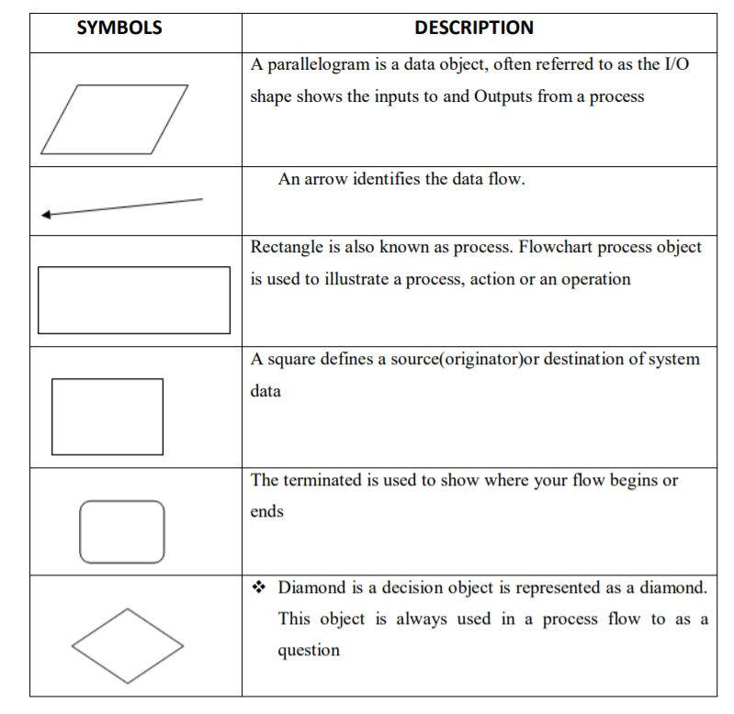

**Table 1: Data flow diagram symbols.**

Level 0:

Add Student

Admin

Enter Login Details

Results

Delete Student

Enter Login Details

Enter Student Roll Number

Update Student Details

Show Student Details

Student

Level 1:

Storage

Student

Admin

Login

Show Results

Remove Student

Enter Student Details

Login

Fetch Student

Add Student

Verify Login Details

Level 2:

Storage

Directed Page

Enter Roll Number

Choose Option

Enter Details

Student

Admin

**ENTITY RELATIONSHIP(ER):**

ER Diagram stands for Entity Relationship Diagram, also known as ERD is a diagram that displays the relationship of entity sets stored in a database. In other words, ER diagrams help to explain the logical structure of databases. ER diagrams are created based on three basic concepts: entities, attributes and relationships. The ER Model represents real-world entities and the relationships between them. Creating an ER Model in DBMS is considered as a best practice before implementing your database. Entity Relationship Diagram Symbols & Notations mainly contains three basic symbols which are rectangle, oval and diamond to represent relationships between elements, entities and attributes. There are some sub elements which are based on main elements in ERD Diagram. ER Diagram is a visual representation of data that describes how data is related to each other using different ERD Symbols and Notations.

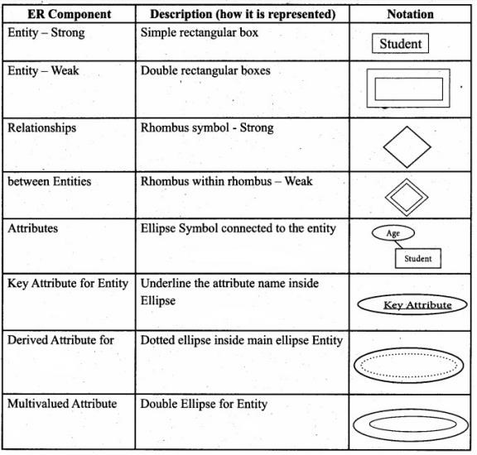

**Table 2: ER diagram symbols.**

**Following are the main components and its symbols in ER Diagrams:**

* **Rectangles:** This Entity Relationship Diagram symbol represents entity types
* **Ellipses:** Symbol represent attributes
* **Diamonds:** This symbol represents relationship types
* **Lines:** It links attributes to entity types and entity types with other relationship types
* **Primary key:** attributes are underlined
* **Double Ellipses:** Represent multi-valued attributes

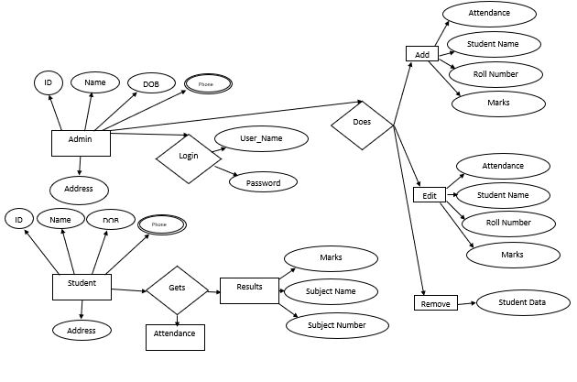

**CHAPTER 4: IMPLEMENTATION & RESULTS**

**4.1 INTRODUCTION:**

Implementation is the stage of the project when the theoretical design is turned out into a working system. Thus, it can be considered to be the most critical stage in achieving a successful new system and in giving the user, confidence that the new system will work and be effective.The implementation stage involves careful planning, investigation of the existing system and its constraints on implementation, designing of methods to achieve changeover and evaluation of changeover methods.

**4.2.1 OUTPUT SCREENS:**

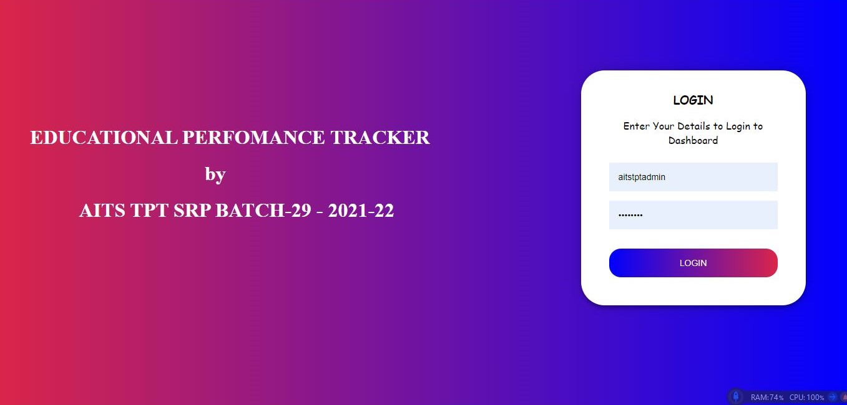

Fig 3.1.1-Login Page for admin

The admin has to enter his credentials to login to the portal.

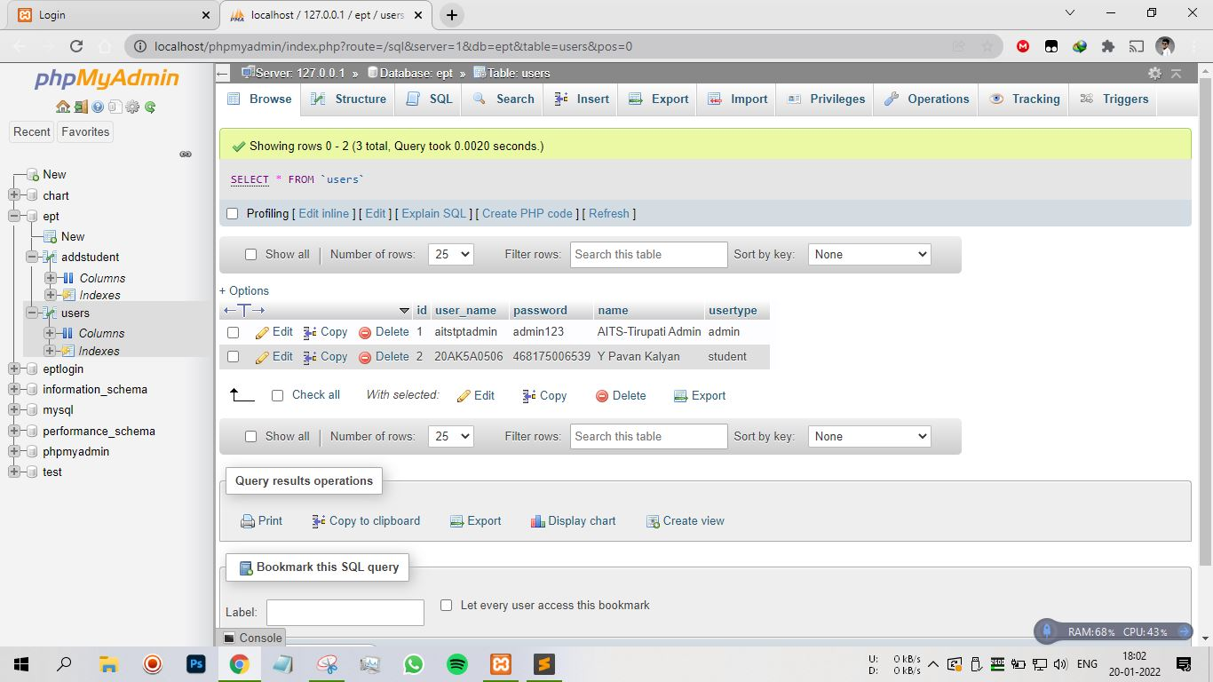

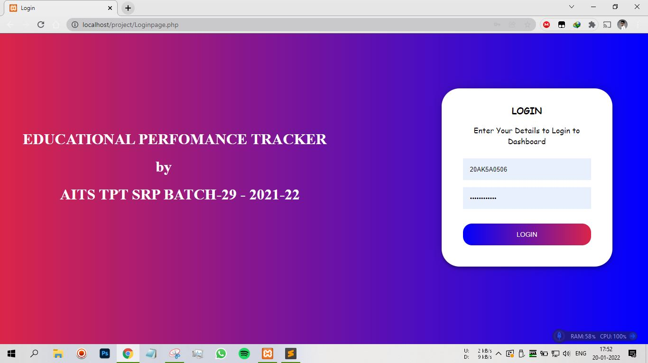

Fig 3.1.2-Login page for student

A student has to enter the credentials given to him by the educational institution he is in.

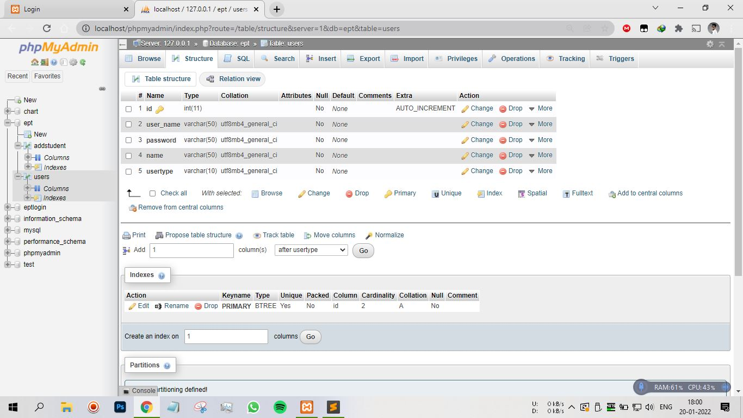

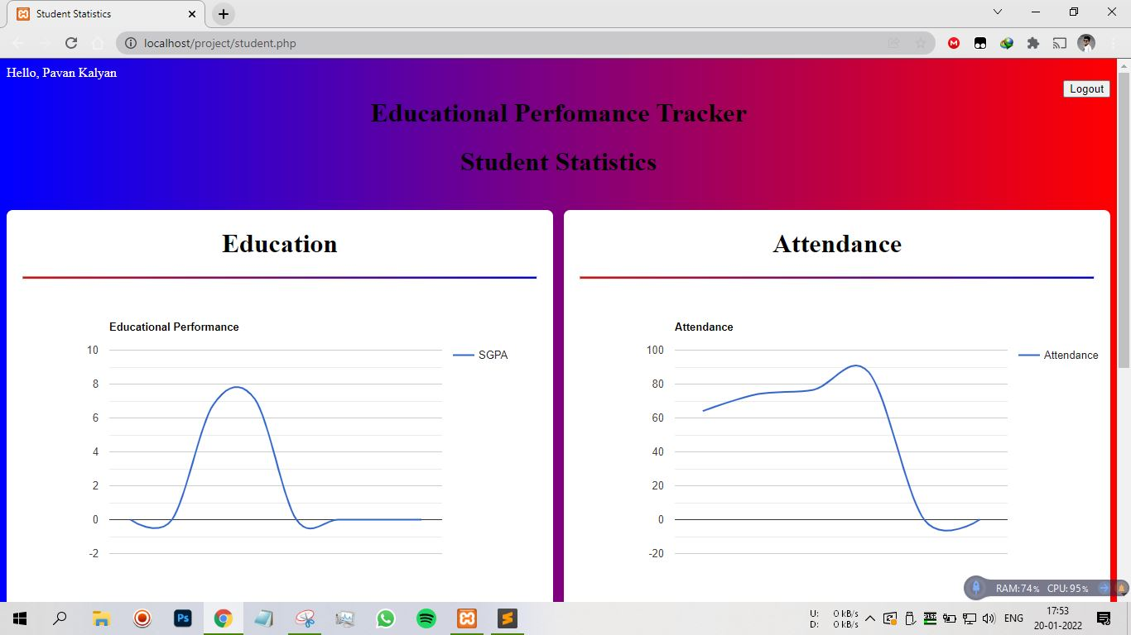

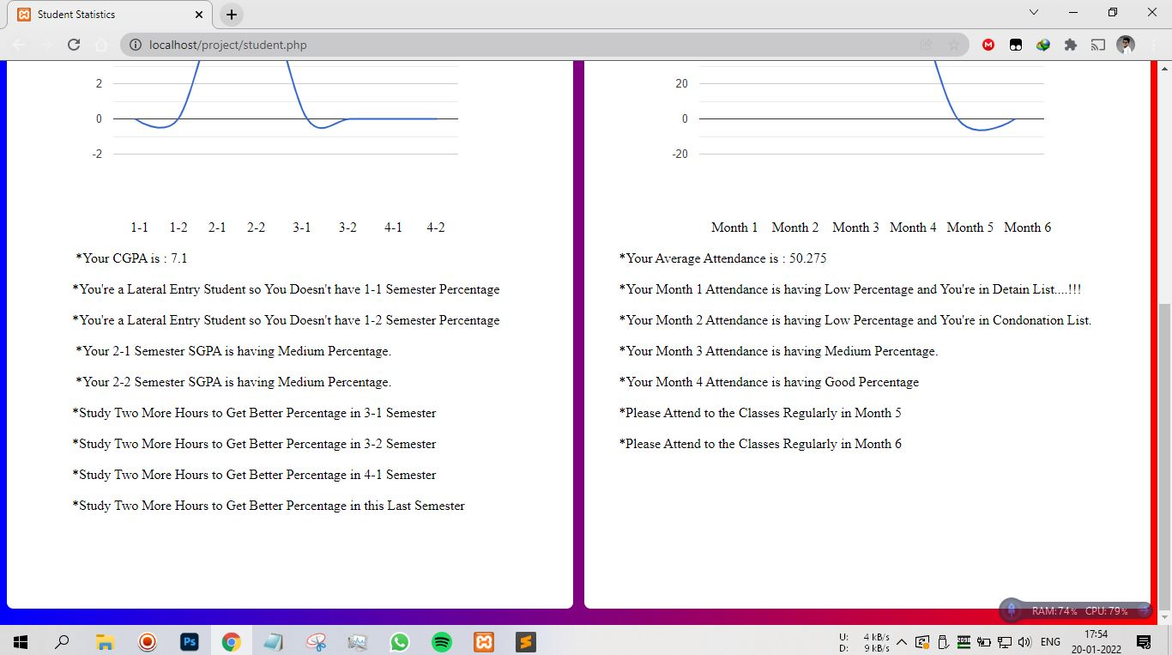

Fig 3.1.3-Student page

After login, the student can view his exam results in a graph represention and get a feedback based on his performance.

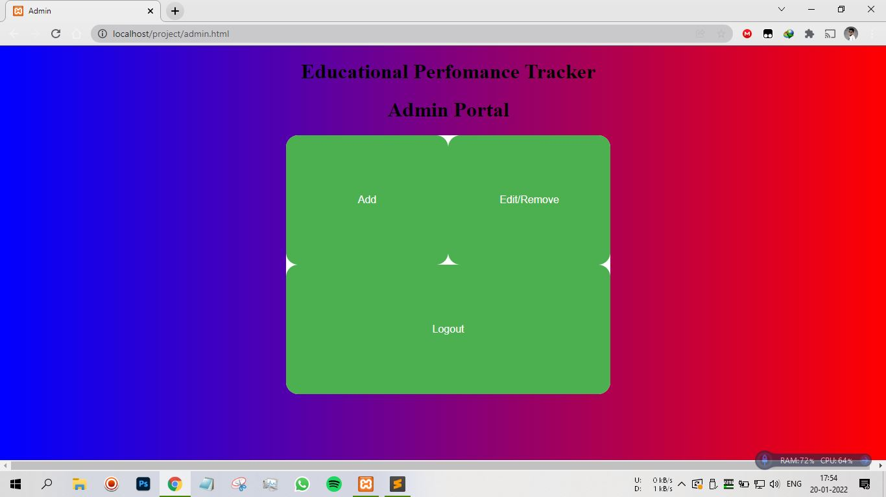

Fig 3.1.4-Admin direcion page

Shows that there are three buttons provided for the admin to move his desired section.

* Add – this button allows the admin to add a new student to the database.
* Edit/Remove – this button allows the amin the edit the details of a student to the database or remove a student from the database.

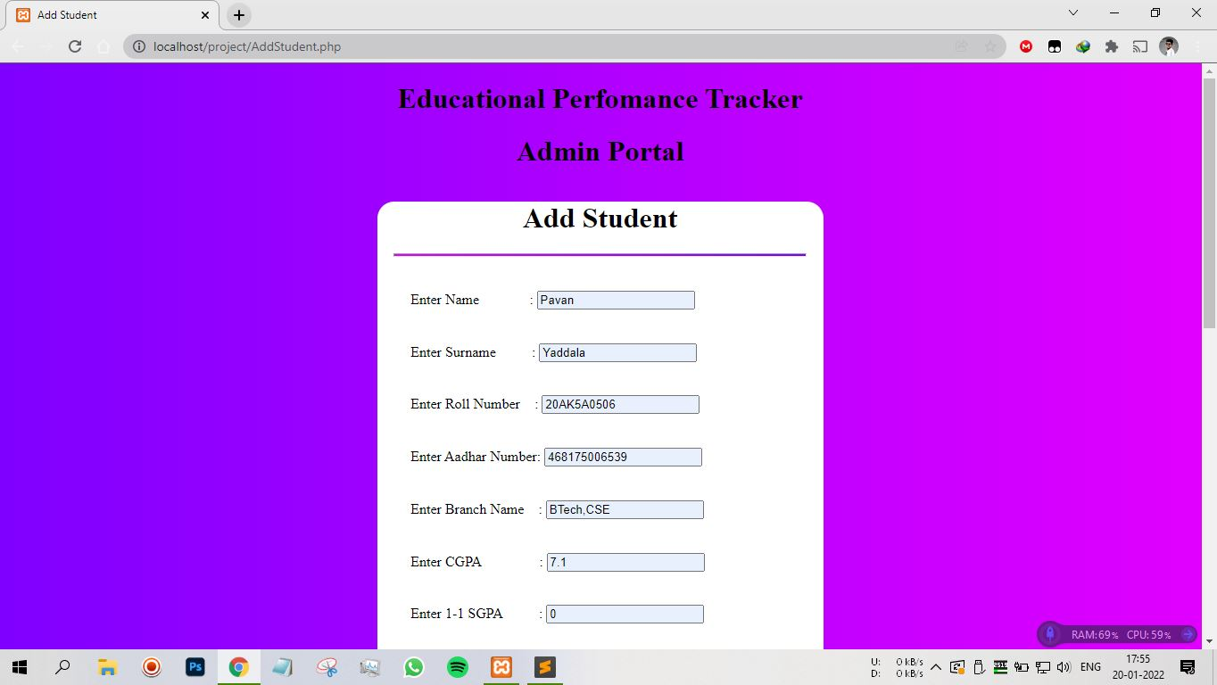

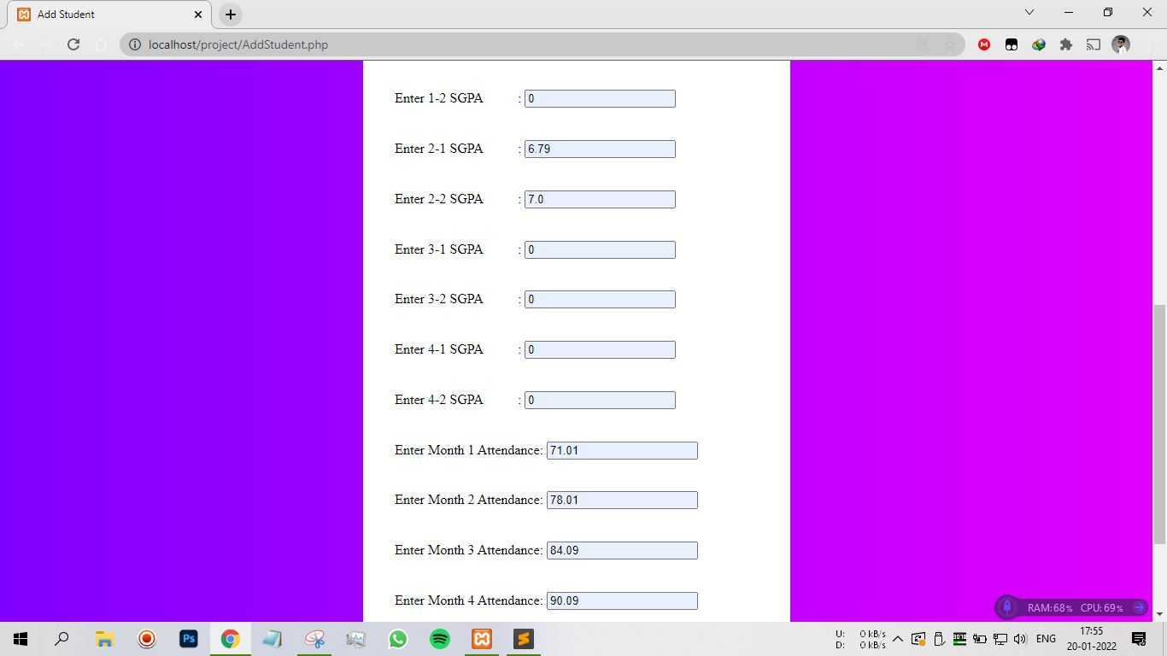

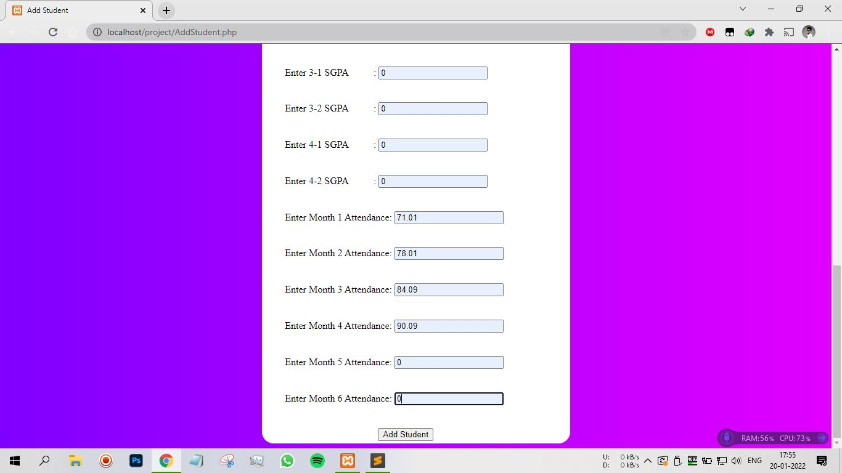

Fig 3.1.5-Add student

* Shows that a admin can use the given form to fill the details of a student he wants to add to the database by clicking on the Add Student button.

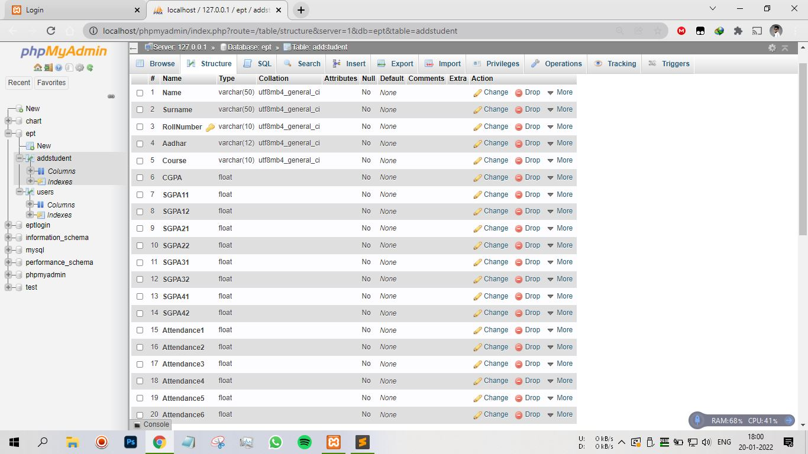

Apicture showing the database side where the details of the student are stored.

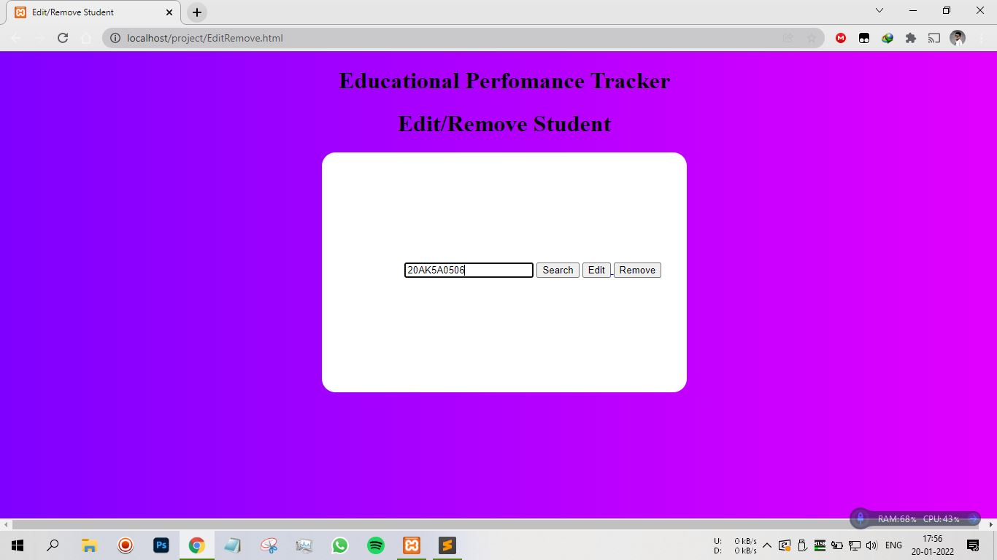

Fig 3.1.6-Edit or Remove Page

* Here, the admin can search for a student’s details upon entering the rollno of the student.

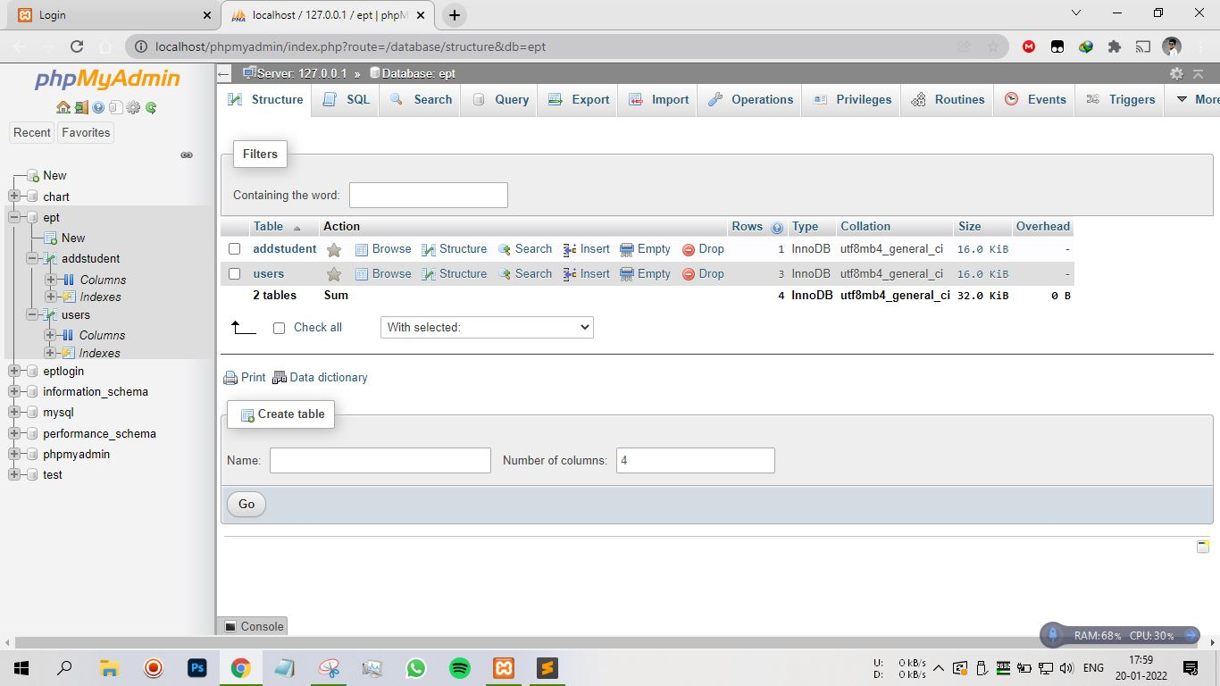

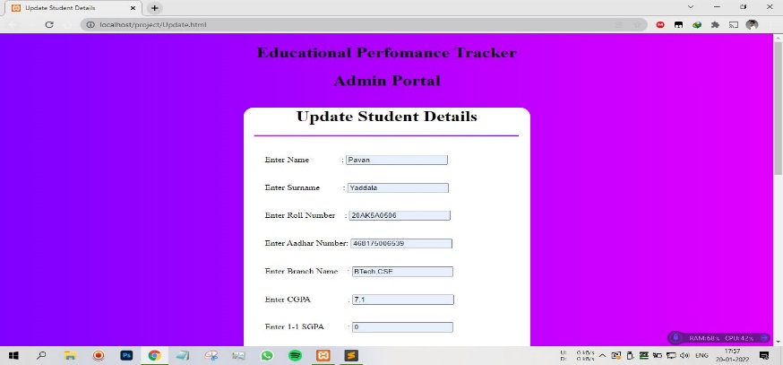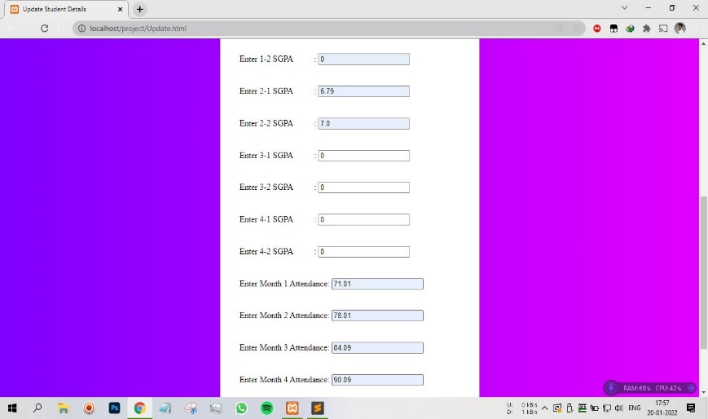

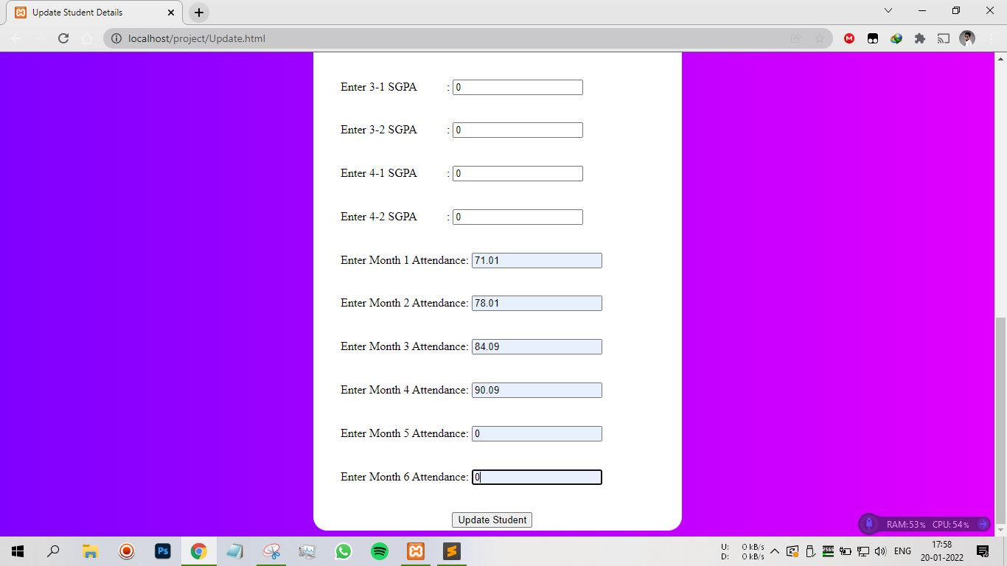

Fig 3.1.7 Update student

* This page allows the admin to edit the details of a student by changing the values in the boxes and clickin on the Update Student button.



The updated student details will be stored in the database as shown above.

**CHAPTER 5: VALIDATION**

**5.1 Introduction:**

Validation is the process of testing the website in different scenarios and validating the final result of all the test cases. Here, we perform various test on the website.

**5.1 Design of test cases and scenarios:**

We design various test cases to check the performance and security of the website.

Following are the test cases we designed:

* Proper working of the website.
* Input of credentials.
* Verifications.

To check whether the website is working properly, we will open each page in a web browser and check for errors.

When a user input his credentials, we have to cross verify it with those stored in the database.

After the verification is complete the user will be able to login and perform actions based on his designation as a student or admin.

**5.1 Validation:**

After the site passes through all the tests successfully, it will be concluded that the website is working properly.

**CHAPTER 6: SAMPLE SOURCE CODE**

Code to implement Educational Performance Tracker:

<!DOCTYPE html>

<html>

<head>

<Title>signinpage</Title>

<link rel="stylesheet" href="style.css">

</head>

<body>

<div class="imggg">

<h1>&emsp;</h1>

<h1>&emsp;</h1>

<h1>&emsp;</h1>

<h1>&emsp; EDUCATIONAL PERFOMANCE TRACKER</h1>

<h1>&emsp; &emsp; &emsp; &emsp; &emsp; &emsp; &emsp; &emsp; by</h1>

<h1>&emsp; &emsp; &emsp; &emsp; &emsp; &emsp; &emsp; BATCH-29</h1>

</div>

<div class="totframe">

<div class="form">

<div class="head">

<h3>LOGIN</h3>

<p>Enter Your Details to Login to Dashboard</p>

</div>

<form class="fill">

<input type="text" placeholder="ID"/>

<input type="password" placeholder="PASSWORD"/>

<input type="radio" id="admin" name="designation" value="ADMIN"/>

<label for="admin">ADMIN</label>

<input type="radio" id="student" name="designation" value="STUDENT"/>

<label for="student">STUDENT</label>

<button>login</button>

</form>

</div>

</div>

</body>

</html>

body

{

background-image: linear-gradient(90deg,rgb(218, 37, 73),blue);

}

.imggg

{

float: left;

width: auto;

color: white;

border-radius: 1cm;

font-size: medium;

}

.totframe

{

width: 360px;

float: right;

padding: 8% 5% 0;

}

.totframe .form .head

{

margin-top: -31px;

margin-bottom: 25px;

font-family: cursive;

}

.form

{

position: relative;

z-index: 1;

background: white;

max-width: 360px;

margin: 0 auto 100px;

padding: 45px;

text-align: center;

border-radius: 1cm;

box-shadow: 0 0 20px 0 rgba(0, 0, 0, 0.2), 0 5px 5px 0 rgba(0, 0, 0, 0.24);

}

.form input[type="text"],[type="password"] {

font-family: "Roboto", sans-serif;

outline: 0;

background: #f2f2f2;

width: 100%;

border: 0;

margin: 0 0 15px;

padding: 15px;

box-sizing: border-box;

font-size: 14px;

}

.form button {

font-family: "Roboto", sans-serif;

margin-top: 4mm;

text-transform: uppercase;

outline: 0;

background-image: linear-gradient(90deg,blue,rgb(218, 37, 73));

width: 100%;

border: 0;

border-radius: 0.5cm;

padding: 15px;

color: #ffffff;

font-size: 14px;

cursor: pointer;

}

<?php

session_start();

if (isset($_SESSION['user_name'])) {

?>

<!DOCTYPE html>

<html>

<head>

<Title>Student Statistics</Title>

<link rel="stylesheet" href="student.css">

</head>

<body>

<div class="welcome">

<label style="color:white;">Hello, <?php echo $_SESSION['name']; echo $_SESSION['surname']; ?></label>

</div>

<div class="logout">

<a href="Loginpage.php">

<button>Logout</button>

</a>

</div>

<div class="pagename">

<h1>Educational Perfomance Tracker</h1>

<h1>Student Statistics</h1>

</div>

<div class="marks">

<h1 id="headi">Education</h1>

<hr id="hrl">

<script type="text/javascript" src="https://www.gstatic.com/charts/loader.js"></script>

<script type="text/javascript">

google.charts.load('current', {'packages':['corechart']});

google.charts.setOnLoadCallback(drawChart);

function drawChart() {

var data = google.visualization.arrayToDataTable([

[' ', 'SGPA'],

<?php

$res=array();

array_push($res,$_SESSION['SGPA11'],$_SESSION['SGPA12'],$_SESSION['SGPA21'],$_SESSION['SGPA22'],$_SESSION['SGPA31'],$_SESSION['SGPA32'],$_SESSION['SGPA41'],$_SESSION['SGPA42']);

$GPA=array(' ');

foreach($GPA as $data2)

{

foreach($res as $data)

{

$SGPA=$data2;

$SGPAvalue=$data;

?>

['<?php echo $SGPA;?>',<?php echo $SGPAvalue;?>],

<?php

}

}

?>

]);

var options = {

title: 'Educational Performance',

curveType: 'function',

};

var chart = new google.visualization.LineChart(document.getElementById('curve_chart'));

chart.draw(data, options);

}

</script>

<div id="curve_chart" style="width: 650px; height: 400px"></div>

<label>&emsp; &emsp;&emsp; &emsp;&emsp; &emsp;&emsp;&emsp; 1-1 &emsp; 1-2 &emsp; 2-1 &emsp; 2-2 &emsp;&ensp; 3-1 &emsp;&ensp; 3-2 &emsp;&ensp; 4-1&emsp;&ensp; 4-2 </label>

<br><br>

<?php

echo "&emsp; &emsp; &emsp; &emsp; *Your CGPA is :&nbsp;",$_SESSION['CGPA'];

if($_SESSION['SGPA11'] < 7.50 && $_SESSION['SGPA11'] > 6.50)

{

echo "</br>";

echo "</br>";

echo "&emsp; &emsp; &emsp; &emsp; *Your 1-1 Semester SGPA is having Medium Percentage.";

}

elseif($_SESSION['SGPA11'] < 6.50 && $_SESSION['SGPA11'] > 5.50)

{

echo "</br>";

echo "</br>";

echo "&emsp; &emsp; &emsp; &emsp; *Your 1-1 Semester SGPA is having Low Percentage.";

}

elseif($_SESSION['SGPA11'] == 0)

{

echo "</br>";

echo "</br>";

echo "&emsp; &emsp; &emsp; &emsp;*You're a Lateral Entry Student so You Doesn't have 1-1 Semester Percentage";

}

if($_SESSION['SGPA12'] < 7.50 && $_SESSION['SGPA12'] > 6.50)

{

echo "</br>";

echo "</br>";

echo "&emsp; &emsp; &emsp; &emsp; *Your 1-2 Semester SGPA is having Medium Percentage.";

}

elseif($_SESSION['SGPA12'] < 6.50 && $_SESSION['SGPA12'] > 5.50)

{

echo "</br>";

echo "</br>";

echo "&emsp; &emsp; &emsp; &emsp; *Your 1-2 Semester SGPA is having Low Percentage.";

}

elseif($_SESSION['SGPA12'] == 0)

{

echo "</br>";

echo "</br>";

echo "&emsp; &emsp; &emsp; &emsp;*You're a Lateral Entry Student so You Doesn't have 1-2 Semester Percentage";

}

if($_SESSION['SGPA21'] < 7.50 && $_SESSION['SGPA21'] > 6.50)

{

echo "</br>";

echo "</br>";

echo "&emsp; &emsp; &emsp; &emsp; *Your 2-1 Semester SGPA is having Medium Percentage.";

}

elseif($_SESSION['SGPA21'] < 6.50 && $_SESSION['SGPA21'] > 5.50)

{

echo "</br>";

echo "</br>";

echo "&emsp; &emsp; &emsp; &emsp; *Your 2-1 Semester SGPA is having Low Percentage.";

}

if($_SESSION['SGPA22'] < 7.50 && $_SESSION['SGPA22'] > 6.50)

{

echo "</br>";

echo "</br>";

echo "&emsp; &emsp; &emsp; &emsp; *Your 2-2 Semester SGPA is having Medium Percentage.";

}

elseif($_SESSION['SGPA22'] < 6.50 && $_SESSION['SGPA22'] > 5.50)

{

echo "</br>";

echo "</br>";

echo "&emsp; &emsp; &emsp; &emsp; *Your 2-2 Semester SGPA is having Low Percentage.";

}

if($_SESSION['SGPA31'] < 7.50 && $_SESSION['SGPA31'] > 6.50)

{

echo "</br>";

echo "</br>";

echo "&emsp; &emsp; &emsp; &emsp; *Your 3-1 Semester SGPA is having Medium Percentage.";

}

elseif($_SESSION['SGPA31'] < 6.50 && $_SESSION['SGPA31'] > 5.50)

{

echo "</br>";

echo "</br>";

echo "&emsp; &emsp; &emsp; &emsp; *Your 3-1 Semester SGPA is having Low Percentage.";

}

elseif($_SESSION['SGPA31'] == 0)

{

echo "</br>";

echo "</br>";

echo "&emsp; &emsp; &emsp; &emsp;*Study Two More Hours to Get Better Percentage in 3-1 Semester";

}

if($_SESSION['SGPA32'] < 7.50 && $_SESSION['SGPA32'] > 6.50)

{

echo "</br>";

echo "</br>";

echo "&emsp; &emsp; &emsp; &emsp; *Your 3-2 Semester SGPA is having Medium Percentage.";

}

elseif($_SESSION['SGPA32'] < 6.50 && $_SESSION['SGPA32'] > 5.50)

{

echo "</br>";

echo "</br>";

echo "&emsp; &emsp; &emsp; &emsp; *Your 3-2 Semester SGPA is having Low Percentage.";

}

elseif($_SESSION['SGPA32'] == 0)

{

echo "</br>";

echo "</br>";

echo "&emsp; &emsp; &emsp; &emsp;*Study Two More Hours to Get Better Percentage in 3-2 Semester";

}

if($_SESSION['SGPA41'] < 7.50 && $_SESSION['SGPA41'] > 6.50)

{

echo "</br>";

echo "</br>";

echo "&emsp; &emsp; &emsp; &emsp; *Your 4-1 Semester SGPA is having Medium Percentage.";

}

elseif($_SESSION['SGPA41'] < 6.50 && $_SESSION['SGPA41'] > 5.50)

{

echo "</br>";

echo "</br>";

echo "&emsp; &emsp; &emsp; &emsp; *Your 4-1 Semester SGPA is having Low Percentage.";

}

elseif($_SESSION['SGPA41'] == 0)

{

echo "</br>";

echo "</br>";

echo "&emsp; &emsp; &emsp; &emsp;*Study Two More Hours to Get Better Percentage in 4-1 Semester";

}

if($_SESSION['SGPA42'] < 7.50 && $_SESSION['SGPA42'] > 6.50)

{

echo "</br>";

echo "</br>";

echo "&emsp; &emsp; &emsp; &emsp; *Your 4-2 Semester SGPA is having Medium Percentage.";

}

elseif($_SESSION['SGPA42'] < 6.50 && $_SESSION['SGPA42'] > 5.50)

{

echo "</br>";

echo "</br>";

echo "&emsp; &emsp; &emsp; &emsp; *Your 4-2 Semester SGPA is having Low Percentage.";

}

elseif($_SESSION['SGPA31'] == 0)

{

echo "</br>";

echo "</br>";

echo "&emsp; &emsp; &emsp; &emsp;*Study Two More Hours to Get Better Percentage in this Last Semester";

}

?>

</div>

<div class="attendance">

<h1 id="headi">attendance</h1>

<hr id="hrl">

<script type="text/javascript" src="https://www.gstatic.com/charts/loader.js"></script>

<script type="text/javascript">

google.charts.load('current', {'packages':['corechart']});

google.charts.setOnLoadCallback(drawChart);

function drawChart() {

var data = google.visualization.arrayToDataTable([

[' ', 'Attendance'],

<?php

$res=array();

array_push($res,$_SESSION['Attendance1'],$_SESSION['Attendance2'],$_SESSION['Attendance3'],$_SESSION['Attendance4'],$_SESSION['Attendance5'],$_SESSION['Attendance6']);

$GPA=array(" ");

foreach($GPA as $data2)

{

foreach($res as $data)

{

$SGPA=$data2;

$SGPAvalue=$data;

?>

['<?php echo $SGPA;?>',<?php echo $SGPAvalue;?>],

<?php

}

}

?>

]);

var options = {

title: 'Attendance',

curveType: 'function',

};

var chart = new google.visualization.LineChart(document.getElementById('curve_chart2'));

chart.draw(data, options);

}

</script>

<div id="curve_chart2" style="width: 650px; height: 400px; float: right;"></div>

<label>&emsp; &emsp;&emsp; &emsp;&emsp; &emsp;&emsp; &emsp; Month 1 &ensp; Month 2 &ensp; Month 3&ensp; Month 4&ensp; Month 5&ensp; Month 6</label>

<br><br>

<?php

$AverageAttendance= $_SESSION['Attendance1']+$_SESSION['Attendance2']+$_SESSION['Attendance3']+$_SESSION['Attendance4']+$_SESSION['Attendance5']+$_SESSION['Attendance6'];

$AverageAttendance=$AverageAttendance/6;

echo "&emsp; &emsp; *Your Average Attendance is :&nbsp;",$AverageAttendance;

if($_SESSION['Attendance1'] < 75.0 && $_SESSION['Attendance1'] > 65.0)

{

echo "</br>";

echo "</br>";

echo "&emsp; &emsp; *Your Month 1 Attendance is having Low Percentage and You're in Condonation List.";

}

elseif($_SESSION['Attendance1'] > 75.0 && $_SESSION['Attendance1'] > 85.0)

{

echo "</br>";

echo "</br>";

echo "&emsp; &emsp; *Your Month 1 Attendance is having Medium Percentage.";

}

elseif($_SESSION['Attendance1'] < 65.0 && $_SESSION['Attendance1'] > 0)

{

echo "</br>";

echo "</br>";

echo "&emsp; &emsp; *Your Month 1 Attendance is having Low Percentage and You're in Detain List....!!!";

}

elseif($_SESSION['Attendance1'] > 85.0 )

{

echo "</br>";

echo "</br>";

echo "&emsp; &emsp; *Your Month 1 Attendance is having Good Percentage ";

}

if($_SESSION['Attendance2'] < 75.0 && $_SESSION['Attendance2'] > 65.0)

{

echo "</br>";

echo "</br>";

echo "&emsp; &emsp; *Your Month 2 Attendance is having Low Percentage and You're in Condonation List.";

}

elseif($_SESSION['Attendance2'] > 75.0 && $_SESSION['Attendance2'] < 85.0)

{

echo "</br>";

echo "</br>";

echo "&emsp; &emsp; *Your Month 2 Attendance is having Medium Percentage.";

}

elseif($_SESSION['Attendance2'] < 65.0 && $_SESSION['Attendance2'] > 0)

{

echo "</br>";

echo "</br>";

echo "&emsp; &emsp; *Your Month 2 Attendance is having Low Percentage and You're in Detain List....!!!";

}

elseif($_SESSION['Attendance2'] > 85.0 )

{

echo "</br>";

echo "</br>";

echo "&emsp; &emsp; *Your Month 2 Attendance is having Good Percentage ";

}

elseif($_SESSION['Attendance2'] == 0 )

{

echo "</br>";

echo "</br>";

echo "&emsp; &emsp; *Please Attend to the Classes Regularly in Month 2";

}

if($_SESSION['Attendance3'] < 75.0 && $_SESSION['Attendance3'] > 65.0)

{

echo "</br>";

echo "</br>";

echo "&emsp; &emsp; *Your Month 3 Attendance is having Low Percentage and You're in Condonation List.";

}

elseif($_SESSION['Attendance3'] > 75.0 && $_SESSION['Attendance3'] < 85.0)

{

echo "</br>";

echo "</br>";

echo "&emsp; &emsp; *Your Month 3 Attendance is having Medium Percentage.";

}

elseif($_SESSION['Attendance3'] < 65.0 && $_SESSION['Attendance3'] > 0)

{

echo "</br>";

echo "</br>";

echo "&emsp; &emsp; *Your Month 3 Attendance is having Low Percentage and You're in Detain List....!!!";

}

elseif($_SESSION['Attendance3'] > 85.0 )

{

echo "</br>";

echo "</br>";

echo "&emsp; &emsp; *Your Month 3 Attendance is having Good Percentage ";

}

elseif($_SESSION['Attendance3'] == 0 )

{

echo "</br>";

echo "</br>";

echo "&emsp; &emsp; *Please Attend to the Classes Regularly in Month 3";

}

if($_SESSION['Attendance4'] < 75.0 && $_SESSION['Attendance4'] > 65.0)

{

echo "</br>";

echo "</br>";

echo "&emsp; &emsp; *Your Month 4 Attendance is having Low Percentage and You're in Condonation List.";

}

elseif($_SESSION['Attendance4'] > 75.0 && $_SESSION['Attendance4'] < 85.0)

{

echo "</br>";

echo "</br>";

echo "&emsp; &emsp; *Your Month 4 Attendance is having Medium Percentage.";

}

elseif($_SESSION['Attendance4'] < 65.0 && $_SESSION['Attendance4'] > 0)

{

echo "</br>";

echo "</br>";

echo "&emsp; &emsp; *Your Month 4 Attendance is having Low Percentage and You're in Detain List....!!!";

}

elseif($_SESSION['Attendance4'] > 85.0 )

{

echo "</br>";

echo "</br>";

echo "&emsp; &emsp; *Your Month 4 Attendance is having Good Percentage ";

}

elseif($_SESSION['Attendance4'] == 0 )

{

echo "</br>";

echo "</br>";

echo "&emsp; &emsp; *Please Attend to the Classes Regularly in Month 4";

}

if($_SESSION['Attendance5'] < 75.0 && $_SESSION['Attendance5'] > 65.0)

{

echo "</br>";

echo "</br>";

echo "&emsp; &emsp; *Your Month 5 Attendance is having Low Percentage and You're in Condonation List.";

}

elseif($_SESSION['Attendance5'] > 75.0 && $_SESSION['Attendance5'] < 85.0)

{

echo "</br>";

echo "</br>";

echo "&emsp; &emsp; *Your Month 5 Attendance is having Medium Percentage.";

}

elseif($_SESSION['Attendance5'] < 65.0 && $_SESSION['Attendance5'] > 0)

{

echo "</br>";

echo "</br>";

echo "&emsp; &emsp; *Your Month 5 Attendance is having Low Percentage and You're in Detain List....!!!";

}

elseif($_SESSION['Attendance5'] > 85.0 )

{

echo "</br>";

echo "</br>";

echo "&emsp; &emsp; *Your Month 5 Attendance is having Good Percentage ";

}

elseif($_SESSION['Attendance5'] == 0 )

{

echo "</br>";

echo "</br>";

echo "&emsp; &emsp; *Please Attend to the Classes Regularly in Month 5";

}

if($_SESSION['Attendance6'] < 75.0 && $_SESSION['Attendance6'] > 65.0)

{

echo "</br>";

echo "</br>";

echo "&emsp; &emsp; *Your Month 6 Attendance is having Low Percentage and You're in Condonation List.";

}

elseif($_SESSION['Attendance6'] > 75.0 && $_SESSION['Attendance6'] < 85.0)

{

echo "</br>";

echo "</br>";

echo "&emsp; &emsp; *Your Month 6 is having Medium Percentage.";

}

elseif($_SESSION['Attendance6'] < 65.0 && $_SESSION['Attendance6'] > 0)

{

echo "</br>";

echo "</br>";

echo "&emsp; &emsp; *Your Month 6 Attendance is having Low Percentage and You're in Detain List....!!!";

}

elseif($_SESSION['Attendance6'] > 85.0 )

{

echo "</br>";

echo "</br>";

echo "&emsp; &emsp; *Your Month 6 Attendance is having Good Percentage ";

}

elseif($_SESSION['Attendance6'] == 0 )

{

echo "</br>";

echo "</br>";

echo "&emsp; &emsp; *Please Attend to the Classes Regularly in Month 6";

}

?>

</div>

</body>

</html>

<?php

}

else

{

header("Location: loginpage.php");

exit();

}

?>

**CHAPTER 7: CONCLUSION & FUTURE ENHANCEMENT**

CONCLUSION:

* This web site will help students in further understanding their progress over the past few years and gives feedback based on their performance.
* The graph constructed on their progress will give visual information to students and helps them in quickly identifying their progress.
* By following the feedback, they can plan better when they are preparing their schedule.

FUTURE ENHANCEMENT:

On Upcoming Future Updates we’ll streamline the existing modules and add a feature for a student to change his password and username. And allow a student to make a schedule in the portal. Allow the student to give feedback to the admin.

**CHAPTER 8: BIBLIOGRAPHY**

**REFERENCES**

* **AITT Student login -** [**https://examinations.aits-tpt.edu.in/SBLogin**](https://examinations.aits-tpt.edu.in/SBLogin)
* **AITT Staff login -** [**https://examinations.aits-tpt.edu.in/StaffLogin**](https://examinations.aits-tpt.edu.in/StaffLogin)
* **Education Tracking-** [**https://en.wikipedia.org/wiki/Tracking_(education)**](https://en.wikipedia.org/wiki/Tracking_(education))
* **JNTU Login -** [**https://studentservices.jntuh.ac.in/oss/login.html**](https://studentservices.jntuh.ac.in/oss/login.html)